**THE HARE AND THE TORTOISE**

one day a hare met a tortoise slowly plodding along the road.

what a slow coach you are laughed the hare . ihave never seen an animal as slow as you

the tortoise took no notice of these rude remarks and just plodded on .the hare then jeered ,you couldn’t catch me if you tried for a year.

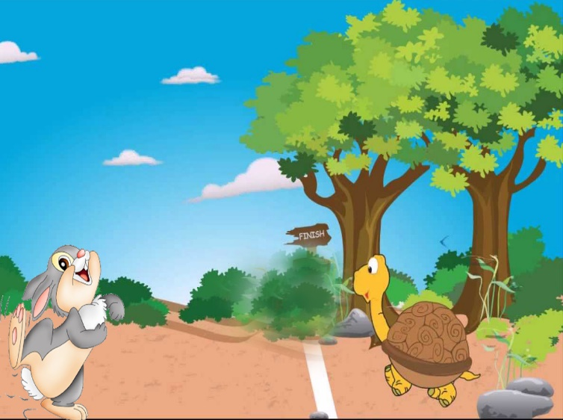

The tortoise then said I will race with you and show you what I can do.

The hare laughed so much that he threw himself about holding his stomach at the tortoise challenge. Alright he said if you want to race with me I will take you on and show you how really fast a hare can run we can race to the big oak tree near the stream.

Right said the tortoise and he slowly started pladding while the hare galloped away .

the hare was so confident that he thought to himself .

That silly old tortoise will take all day to get to9 the oak tree . I can just lie down and have a nice little rest before I go further .with that he lay down and went to sleep

Mean while the tortoise didn’t stop for anything and just kept plodding on after a while he passed the hare sleeping beside the road .he just kept on .

Later the hare woke up and remembered that he was in fact having a race . he leapt up and raced away at a great speed only then did he see that the tortoise was already at the oak tree and had won the race.

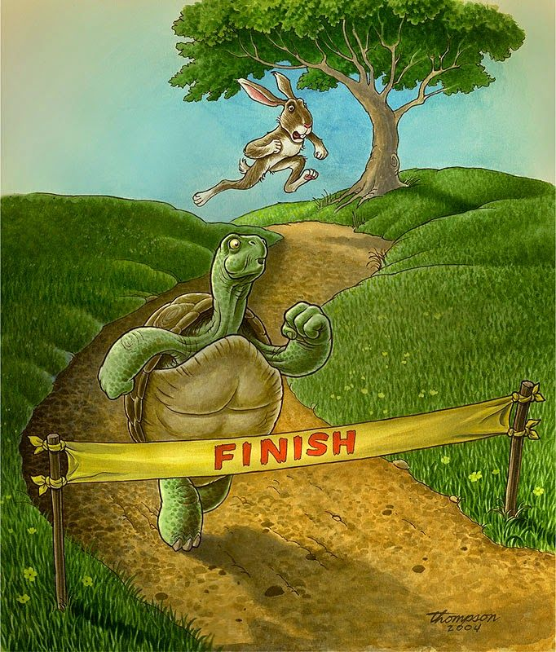

**MORAL : Slow and steady wins the race.**